# Proof of Income

### Step 1: Access the Resident’s profile

* Use the Quick Search feature to search for the Resident’s name in the system.
* A screenshot of a computer

  Description automatically generatedOnce you find the correct Resident’s, navigate to their profile to begin the verification process.

### Step 2: Upload Proof of Income Document

* Click on the **"Add Document"** button.
* Select the appropriate document to upload. This may include, but is not limited to:
  + **Paystubs** (most recent, 1 month for standard or 2–4 if bi-weekly/weekly).
  + **Bank Statements** (3 months of checking or savings with consistent deposits).
  + **Offer Letter** (with company name, start date, compensation details).
  + **Other Verified Income** (W-2s, 1099s, Social Security, Alimony, Disability, etc.).
* Ensure the document is complete, legible, and includes the correct details (e.g., employee name, company name, gross income, etc.).

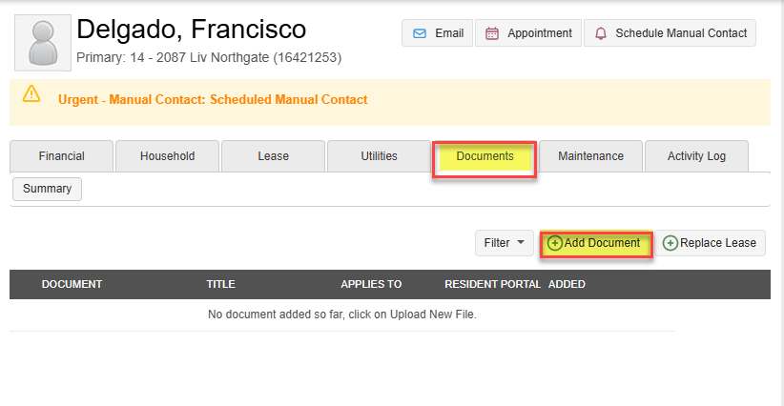

### Step 3: Verify the Proof of Income Document

* **Paystubs**: Ensure that each paystub shows:
  + Company name, employee name, pay period, and **gross income**.
* **Bank Statements**: Verify:
  + The account is under the applicant’s name.
  + The statements show **consistent deposits** (not returns) for the last 3 months.
* **Offer Letter**: Confirm the following details are included:
  + Company name, employee name, job title, **salary or hourly wage**, start date, and projected hours of work.
* **Other Income** (e.g., SSI, Child Support, Alimony):
  + Ensure statements include **start dates**, names, and amounts of income.

## Income Calculation

To qualify, a prospect must have a **gross monthly income** that is **3 times the total base rent** (or **4 times** if a guarantor is required). **Income is calculated based on their GROSS take-home (before taxes)**. Please note that the rent-to-income ratio is differ based on the property. Follow these steps:

1. **Calculate Total Base Rent**:  
   The base rent is **$1,582**, which is the amount you will use for calculations. Do **not** include additional premiums like Liv Bundle or dog rent.
   * **Base Rent** = **$1,582**.
2. **Multiply by 3 (or 4 for Guarantor)**:  
   Multiply the **total base rent** by 3 to find the required **monthly income**.
   * **Example**: $1,582 x 3 = **$4,746** required monthly income.
3. **Verify Income**:  
   Check the applicant’s documents (paystubs, bank statements, offer letters) to ensure the **gross monthly income** meets or exceeds **$4,746**.
   * For **bank statements**, calculate the average monthly deposits over the last 3 months.
   * If paystubs and bank statements are provided, do not allow income to be counted twice in the event the paystub deposits show on the bank statements.



## Annual Income Calculation

When verifying income from **offer letters** or **large sum accounts**, use the total **months of the lease term** to calculate the required annual income or lump sum.

Example Offer Letter:

**How to Calculate**:

1. **Determine the Lease Term**:  
   Identify the **total months** of the lease term (e.g., 12 months).
2. **Calculate Annual Rent**:  
   Multiply the **base rent** by the number of months in the lease term.
   * **Example**:
     + **Base Rent** = $1,000
     + **Lease Term** = 12 months
     + **Annual Rent** = $1,000 x 12 = **$12,000**
3. **Multiply by 3 (Income Requirement)**:  
   Multiply the **annual rent** by 3 to determine the required **annual income**.
   * **Example**:
     + $12,000 x 3 = **$36,000**
4. **Verify Income**:  
   Ensure that the applicant's **annual income** (from offer letters or lump sum accounts) meets or exceeds the required amount (e.g., $36,000).

### Calculating Income with Bank Statements

Total amount of deposits into the bank account per month. This only includes **consistent deposits** and excludes “returns” on goods and services. Statements must show **all transactions**, and not just the overview.  
**\*\*This example does not include the FULL month worth of deposits as it is too large to fit here**\*\*

1. **Gather Bank Statements**:  
   Obtain **three full months** of bank statements, showing all transactions (not just the overview).
   * Example: January 2024, February 2024, March 2024, if moving in April 2024.
2. **Identify Consistent Deposits**:  
   Focus on **consistent deposits** (e.g., income payments) and exclude any **returns** or non-regular transactions.
3. **Calculate Total Deposits**:  
   Add the total amount of **consistent deposits** for each of the three months.
4. **Calculate Average Monthly Income**:  
   After adding the total consistent deposits, divide that total by **3** to get the average monthly income.
   * **Division by 3** is necessary to calculate the average monthly income based on the three months of bank statements collected.

Examples that are linked to this document:

### Step 4: Label and Categorize the Document

* **Name the Document** as **“Proof of Income”** to maintain consistency across records.
* **Label the Document Type** as **Proof of Income** in the system so it is correctly categorized.

### Step 5: Final Check

* Ensure that all required documents are uploaded, verified, and appropriately named and categorized.
* Double-check that the document clearly verifies the **gross income,** and the applicant meets the income requirement (3x the rent amount, or 4x for guarantors).
* Submit and confirm the document is correctly saved in the system.

## Additional Notes:

* Paystubs must show gross income, not just net take-home pay.
* Bank Statements should not just show the overview; verify individual deposits for consistency.
* Offer Letters must be signed by both the applicant and employer and contain details about salary, start date, and projected hours.